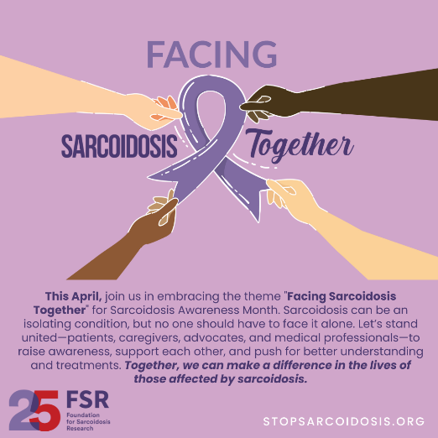
Sarcoidosis Awareness Month 2025
Social Media Toolkit

Facing SARCOIDOSIS together | SOcial Media Toolkit Overview
Welcome to the Sarcoidosis Awareness Month Toolkit for 2025!
This toolkit is your comprehensive resource for raising awareness for sarcoidosis throughout April's 2025 Sarcoidosis Awareness Month.
This April, Sarcoidosis Awareness Month is extra special as the Foundation for Sarcoidosis Research (FSR) celebrates 25 years of dedication, advocacy, and groundbreaking research. Since 2000, FSR has been at the forefront of empowering the sarcoidosis community, advancing research, and striving for better treatments and a cure. As we mark this milestone, we invite you to join us in raising awareness, amplifying voices, and honoring the progress made over the past 25 years—while continuing the urgent work that lies ahead. Together, we can make a lasting impact!
The theme for this year's awareness month is "Facing Sarcoidosis Together”
Facing Sarcoidosis Together:
Living with sarcoidosis presents significant challenges, but no one should have to face them alone. This year’s theme, "Facing Sarcoidosis Together," highlights the power of community, support, and advocacy in navigating this complex disease. Whether you are a patient, caregiver, advocate, or medical professional, we stand stronger when we unite to raise awareness, amplify voices, and push for better treatments. By working together, we can bring hope, understanding, and meaningful change to those impacted by sarcoidosis.
Key Features:
Raising Awareness: Learn effective ways to communicate the impact of sarcoidosis and encourage open dialogue about the condition. Use our resources to educate your community and emphasize the importance of standing together in support of those affected.
Social Media Engagement: Harness the power of social media to foster conversation and raise awareness about sarcoidosis. Use our recommended posts, hashtags such as #FacingSarcoidosisTogether #StopSarcoidosis #SarcoidosisAwareness #PostinPurple, and tagging guidelines to amplify your message and connect with others.
Email Outreach: Access pre-written email templates to engage your network and encourage participation in Sarcoidosis Awareness Month activities. Personalize these templates to resonate with your audience, strengthen community support, and inspire action.

How to Use This Toolkit:
- Familiarize yourself with the provided resources and key messaging, incorporating the theme of "Facing Sarcoidosis Together."
- Tailor your outreach efforts to suit your audience and chosen platforms (Facebook, Twitter, Instagram, LinkedIn, TikTok).
- Utilize the #FacingSarcoidosisTogether #StopSarcoidosis #SarcoidosisAwareness #PostinPurple hashtags in your social media posts to amplify your message and foster community support.

General Social Media Tips
Make sure you are connected with FSR on our various social media platforms so you can tag and share your posts and then FSR can repost with our community! | Tag FSR in your posts so we can share/amplify!  Facebook: @StopSarcoidosis  X(Twitter): @StopSarcoidosis  Instagram: @StopSarcoidosis  Tiktok: @StopSarcoidosis  LinkedIn: @Foundation for Sarcoidosis Research
Hashtags:  - #FacingSarcoidosisTogether  - #StopSarcoidosis  - #PostInPurple  - #SarcoidosisAwareness | Tips:  - Personalize posts for your social media followers  - Encourage your social media followers to get involved and spread the word

Social Media Tips
Platform Type | Platform Tip
Facebook   | - Share your link to your Facing Sarcoidosis Together fundraising page directly into your Facebook posts.  - Reshare posts from FSR’s Facebook page  - Reshare FSR’s website stopsarcoidosis.org  - For the month of April, save the link to your page in your bio.  - Tag FSR on Facebook: @StopSarcoidosis
Instagram   | - Include the link to your Facing Sarcoidosis Together fundraising page in your bio.  - Throughout April, post photos or add videos to your stories and tag FSR at @StopSarcoidosis
Twitter   | - Post the link to your Facing Sarcoidosis Together fundraising page in your bio and tweet when you are making progress towards your goals.  - Tag FSR on Twitter: @StopSarcoidosis
TikTok   | - Include the link to your Facing Sarcoidosis Together fundraising page in your bio.  - Throughout April, post videos and tag FSR at @StopSarcoidosis
LinkedIn   | - Share with your network that you are participating in Sarcoidosis Awareness Month during April by highlighting the theme: Facing Sarcoidosis Together  - Include the link to your Facing Sarcoidosis Together fundraising page in your posts.  - Tag FSR on LinkedIn: @Foundation for Sarcoidosis Research

General Social Media Posts
*Do not forget to tag FSR on your posts so we can reshare! How to tag: @stopsarcoidosis
*Note* - Your profile must be set to PUBLIC for FSR to see your posts and reshare!
Ready to raise awareness this April?
Check out these posts you can use throughout the month! Share your personal journey with sarcoidosis or highlight key facts and statistics about the disease to educate others.
Encourage your friends and family to participate in community events or donate to sarcoidosis research to show their support.
Together, we can stand strong and Face Sarcoidosis Together to make a difference in the lives of those affected.
#FacingSarcoidosisTogether #StopSarcoidosis #PostInPurple #SarcoidosisAwareness

World Sarc Day Social Media Posts
Join us on April 13th to celebrate World Sarcoidosis Day! Show your support by wearing purple alongside @stopsarcoidosis in solidarity with everyone facing sarcoidosis.
Snap a selfie in your favorite purple shirt, hat, scarf, or any other items you use to #PostInPurple, and share it on social media to help raise awareness.
Together, let's stand strong and Face Sarcoidosis Together!
Learn more at stopsarcoidosis.org.
#FacingSarcoidosisTogether #StopSarcoidosis #SarcoidosisAwareness #PostInPurple #WorldSarcDay

Share Why I SAY SARCOIDOSIS
Join Us in Facing Sarcoidosis Together This April!
This Sarcoidosis Awareness Month, we encourage you to raise awareness, share facts, and show support for those affected by sarcoidosis. Here are some ways you can get involved:
- Wear and Post in Purple – Show your support by wearing purple and sharing a photo with #PostInPurple to spread awareness.
- Share a Fact – Educate your community by posting a fact about sarcoidosis and using #FacingSarcoidosisTogether to start conversations.
- Attend an Event – Find local or virtual events to connect with others and learn more about sarcoidosis.
- Donate – Support sarcoidosis research and advocacy efforts to help improve lives.
Need inspiration for your post? Here are some examples:
🟣 "I’m wearing purple and sharing facts about sarcoidosis this April to support those affected. Let's raise awareness and stand together! #FacingSarcoidosisTogether #PostInPurple"
🟣 "Sarcoidosis is often misunderstood, but we can change that. I'm spreading awareness this month—join me! #StopSarcoidosis #SarcoidosisAwareness"
🟣 "Together, we can bring attention to sarcoidosis and support those living with it. Let’s make an impact! #FacingSarcoidosisTogether #PostInPurple"

Contribution Requests
Join the Movement: Facing Sarcoidosis Together
This Sarcoidosis Awareness Month, rally your community and invite them to Face Sarcoidosis Together by spreading awareness, sharing facts, and supporting those affected by this disease.
Some ways to get involved:
🟣 "This April, I am using my voice to raise awareness and support those impacted by sarcoidosis. Join me in spreading the word and standing in solidarity! Together, we can make a difference. #FacingSarcoidosisTogether #StopSarcoidosis #SarcoidosisAwareness"
🟣 "Sarcoidosis is often overlooked, but this month, I am making it my mission to talk about it wherever I go—whether with friends, family, or in my community. Let's raise awareness and support those living with this disease. #PostInPurple #FacingSarcoidosisTogether #SarcoidosisAwareness"
🟣 "Join me in taking action this April! Wear purple, share facts, donate, and help bring awareness to sarcoidosis. Together, we can amplify our voices and make an impact. #FacingSarcoidosisTogether #PostInPurple #StopSarcoidosis"

Social Media Graphics
